EC CHM Project
EUNIS 2 - Installation guide



Modification history
Date | Version | Author | Reason for modification
 | 0.1 | Cristian Romanescu (Finsiel) | First draft
04 Dec. 2003 | 0.2 | Cristian Romanescu (Finsiel) | Added Troubleshooting section
02 Nov.2005 | 2.0 | Cristian Romanescu  (Finsiel) | Document updated for EUNIS v. 2
18 Sept. 2006 | 2.2 | Cristian Romanescu  (Finsiel) | Document updated. Revised installation instructions
Table of Contents
1 Introduction 4
1.1 Purpose of this document 4
1.2 Structure of this document 4
1.3 Field of application 4
1.4 Deviations from PMP 4
1.5 Reference and applicable documents 4
1.6 Terminology 5
1.6.1 Abbreviations, acronyms and definitions 5
1.6.2 Definitions 5
2 General software requirements 6
3 Using the automated installation setup – the EUNIS installation kit 7
3.1 Introduction to setup 7
3.2 Running the setup step by step 7
3.3 Troubleshooting installation 14
4 Setting up MySQL database platform 15
4.1 Download and installation 15
4.2 Setting the database access rights 15
4.3 Setting the server runtime parameters 16
5 Setting up Java Runtime Environment 18
6 Setting up Apache HTTP server 19
7 Setting up the Tomcat servlet engine 20
8 Setting Apache to use Tomcat 21
9 Setting up EUNIS application 22
9.1 Importing EUNIS database 22
9.2 Setting up the web application from source distribution 22
9.3 Setting up the web application from binary distribution 25
10 Running and using the EUNIS 27
11 EUNIS Troubleshooting guide. 28

Introduction

Purpose of this document
This document describes the installation and configuration procedures for the EUNIS Database web application.

Structure of this document
See Table of Contents.

Field of application
Contract | CWU Title | CWU Code
ENV.B.2/SER/2004/0102 | EUNIS web application | WU.3

The content of this document will support the usage of the EUNIS 2 web application and related products.

Deviations from PMP
N/a.

Reference and applicable documents

Code | Title | DATE
CHM-EW1-PMP-001 | Project Management Plan | 17 Feb 2005
CHM-CW6-ADD-002 | EUNIS functions and data analysis | 03 Jan 2001
CHM-BW4-DNC-002 | EUNIS – Species Data Base | 28 May 2001
CHM-DW3-CNT-001 | EUNIS Data Base with Sites | 03 Mar 2003
CHM-DW3-CNT-003 | EUNIS 2 Database design | 10 Dec 2005
CHM-DW3-CNT-004 | EUNIS 2 Database Tool Net – User guide | 11 Dec 2005
CHM-DW3-CNT-005 | EUNIS 2 – User Guide | 10 Dec 2005

Terminology

Abbreviations, acronyms and definitions
EC | European Commission
EUNIS | European Nature Information System
EDTN | EUNIS Database Tool Net
ETC/NPB | European Topic Centre / Nature Protection and Biodiversity
EDTN | EUNIS Database Tool NET
CHM | Clearing-House Mechanism
ROD | Reporting Obligations Database
MoE | Ministry of Environment
WU | Contractual Work Unit
EEA | European Environment Agency
EIONET | Environmental Information and Observation Network
IG | Interest Group (in CIRCA)
NFP | National Focal Point
SA1 | 1st Specific Agreement
SA2 | 2nd Specific Agreement
SA3 | 3rd Specific Agreement
SA4 | 4th Specific Agreement
PMP | Project Management Plan
n/a | Not applicable

Definitions
CIRCA or CIRCLE | The extranet tool developed under the IDA Programme and which constitutes the kernel of the EIONET system; CIRCLE is the name given to the tool in EIONET whereas CIRCA is the name of the tool to be used across Europe.
Interest Group | CIRCLE (i.e. CIRCA) is organized around Interest Groups i.e. a private workspace for a group of people that need to collaborate to achieve common objectives and tasks.
Interest Group Leader | In the context of CIRCLE, the Interest Group Leader is granted extended privileges to administrate, manage and customize the Interest Group. S/he defines users and grant access rights within the Interest Group.

General software requirements

EUNIS 2 web application has been tested to run on the following platforms:
- Linux
- Microsoft Windows 2000/XP

Linux installation preliminaries:

The user should prepare a box with Linux having the following applications installed:
- MySQL database platform 5.0 or better
- Java Software Development Kit (SDK) 1.5.x
- Apache HTTP server 1.x or 2.x
- Mod_jk 2 Apache plugin
- Ant (required for source-based deployment)

Windows installation preliminaries:

The user should have the following applications installed:
- MySQL database platform 5.0 or better
- Java Software Development Kit (SDK) 1.5.x
- Apache HTTP server 1.x or 2.x
- Mod_jk 2 Apache plugin
- Ant (required for source-based deployment)

Details on how to install these applications are found in the installation guides for each application.
All these applications are free and can be downloaded from Internet. (www.mysql.org, www.apache.org, www.java.sun.com.)

Using the automated installation setup – the EUNIS installation kit

Introduction to setup
EUNIS database comes with an automated tool, which can be used as alternative to manual installation.
Even if the installer is automated, you must manually set and verify all the security related settings for the application as will be described.
You need to run the setup with system administration (root) privileges as this will assure read/write rights to all directories where setup files needs to be deployed.
The installation kit is available from the EEA. Users should contact eunis@eea.eu.int.

Running the setup step by step
Setup program will be launched from installation media (CD, Hard disk) by using one of the provided scripts, depending the platform you are using: ‘setup.bat’ for Windows platform or ‘setup.sh’ for Linux platform. Running directly from CD-ROM would not create the setup log, thus we recommend to copy first the whole content to a temporary directory on the hard drive.
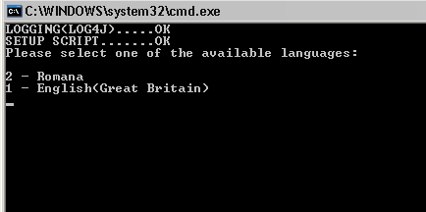
Language selection
First, select the language for the application. Application will detect the available translations and will present the list of languages that can be used during the installation process.

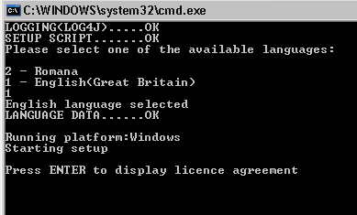

Licence agreement
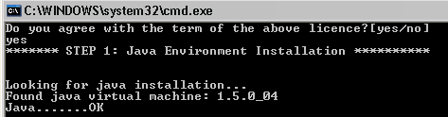Read terms of the licence agreement which EUNIS Database 2 application is distributed under. Type ‘yes’ to accept the terms and to proceed to next step.

Java Environment check:
Application will automatically try to detect if you have the correct Java virtual machine installed on your system. This is done by executing the ‘java --version’ command and analyzing it’s output. This implies that the java executable is included into PATH environment variable. On a correctly installed system java will be included in PATH variable and JAVA_HOME environment variable will point to the directory where Java is installed. This is not necessary however and if the detection fails, but you know that Java is correctly installed, you may choose to skip this step.

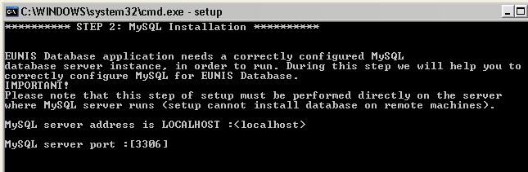

MySQL configuration
Before proceeding please install MySQL server and consult its documentation regarding common configuration for your platform. Also make sure that MySQL will be installed with UTF-8 as its primary encoding.
Installation of the EUNIS database requires running this step directly on the server where MySQL server is installed. (If you have different computers for database server and web server, run the setup on the computer where MySQL runs. On that machine you will skip the Java step and perform the MySQL installation step only).
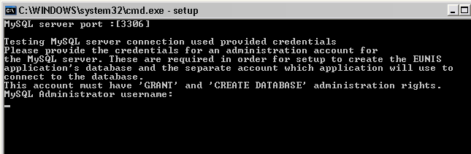Enter the MySQL port (usually 3306) or press ENTER to accept default value if you do not run MySQL on a different port.
Enter the credentials (username and password) for the MySQL administrator; setup needs to create the account, which will be used by EUNIS application to connect to database server. This administration account is usually created during MySQL installation.
Setup will try to connect to the server and check if the credentials were correct and will notify you of the result of the operation as shown below.
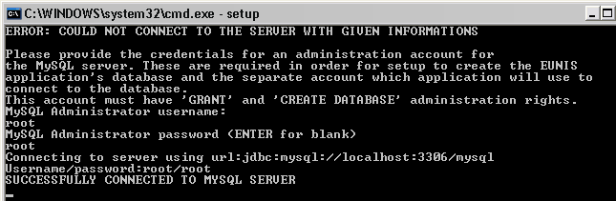

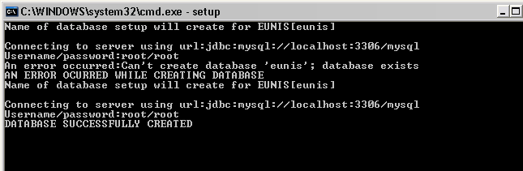
Next setup will ask the name for the EUNIS database. You may choose to use the default provided name (‘eunis’). Please note that database name is unique among the databases which MySQL manages otherwise setup will be unable to create the database.
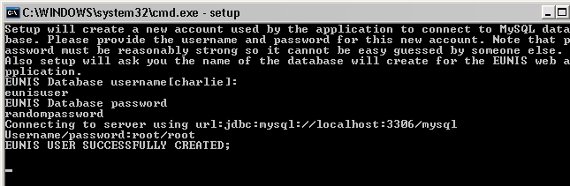EUNIS database application will need a separate account to connect to MySQL. This account will be created by setup and will have limited access only to EUNIS database. You must provide the credentials (username/password) for this new account.

Decompressing database tables
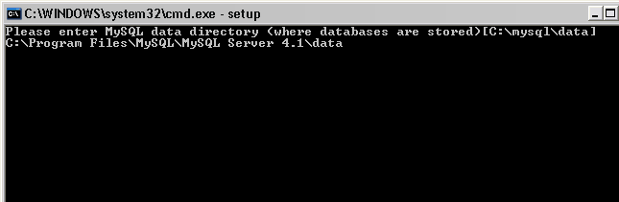When setup created the EUNIS database, a directory matching database name was created on MySQL’s ‘data’ directory. This ‘data’ directory is located usually within MySQL installation directory. Setup will ask you the location of this directory in order to check if EUNIS database directory was created and to decompress the database tables within that database directory. You must insert that path as displayed in the following screen.

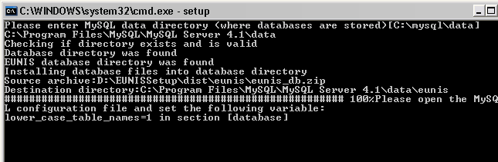Setup will do the checks and will start decompress the database tables. Please make sure that you have about 2GB of free space. When it finishes will ask you to modify the MySQL settings variable ‘lower_case_table_names’ to 1 (See MySQL manual provided on installation media).

Tomcat configuration
Make sure that you have installed Jakarta Tomcat into the server machine. Provide the directory where your tomcat installation is located
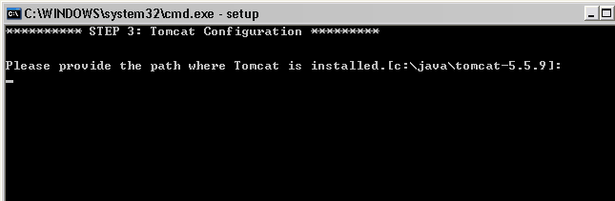
Provide the directory where tomcat ‘webapps’ directory is located (on some systems such as Linux this path may not be located within tomcat installation directory)
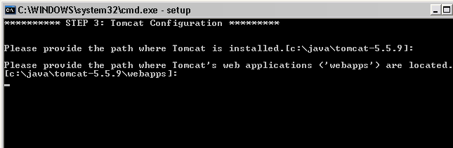

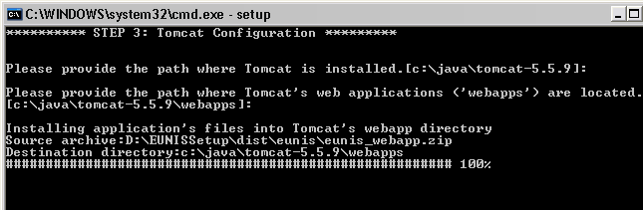

Setup will decompress the EUNIS web application within tomcat’s ‘webapps’ directory

Next setup will ask you the settings for the EUNIS web application
- Domain name – domain where application will run (for example www.mydomain.org/eunis). Note that ‘/eunis’ in the end of the domain will be required unless you set tomcat’s ‘/’ directory to point to ‘eunis’ directory. This is beyond the scope of this guide and requires modification of the server.xml configuration file from tomcat’s ‘conf/’ directory. Also the port 8080 is the default TCP port for tomcat, which can also be modified from the same server.xml file to serve the standard TCP 80 port, the common HTTP port.
- DiGIR URL provider – URL of the DiGIR provider. Since the DiGIR provider is not shipped with the application, you may leave this field to its default value which points to the central EEA DiGIR provider.
- Static part of the page title – Title of the web page as will appear on user’s browser. You may choose to customize this string to your organization.
- Feedback address is where all the user’s feedback will be sent from the application
- SMTP server – address of the mail server used to deliver the e-mails. Also you will be asked credentials if the SMTP server requires authentication to send e-mails
- Sender e-mail address. This e-mail address identifies all the e-mails sent by EUNIS. Some SMTP servers may refuse to send e-mails if they do not recognize a domain, so you may want to specify here a valid address for your domain, for example: eunis@mydomain.org.
- Address of the EEA map server and image type served (gif/jpg). This is the place from which EUNIS will retrieve map images and the format of the images. These parameters do not change too often so it’s best to leave the defaults.
- Proxy server – is required only if your computer is located beyond a firewall.

These parameters may be changed later by editing the ‘web.xml’ configuration file of the application.

Finishing setup and setting the security

This is the last step performed in a production system and required for the application to work properly.
It is best to be performed by hand. System administrators usually personalize security configuration on production systems and there is no standard way to detect how each service (MySQL, Apache, Tomcat) is configured to run (for example local account credentials)
There are two main security settings related to: MySQL, Tomcat and EUNIS application.
- MySQL – Setup process being performed using administrator privileges (root), created database files within MySQL’s data directory with owner of the files inherited from the owner of the process created the files, which is administrator. This is required to change to the user running MySQL service (most commonly on Linux distribution MySQL user is named ‘mysql’).
The command used in Linux is ‘chown'. See steps 4, 5 and 6 from the Chapter 9.1. ‘Importing EUNIS Databases’.
- Tomcat – Similar as in MySQL, files created into tomcat’s webapps directory will have administrator owner. Follow the instructions from the chapter 9.2 ‘Setting up the web application from source distribution’
- Modify the Tomcat to serve pages within UTF-8 format as instructed within chapter 7.

Troubleshooting installation
Here will be presented some of the troubleshooting guidelines to help install the application using installation setup.
1. Disk space – Make sure that you have enough disk space for the installation to take place. At this time whole installation size is about 1.9GB.
2. Error creating database – Make sure that a database with same name does not exists previously.
3. The web application does not work or pages appear odd – Check if the application does connect to the database. To see if any error occurred, check the tomcat log files. These are located usually in the following places: Linux - /var/log/tomcat5, Windows – logs/ directory on tomcat installation directory.
4. Cannot upload pictures of species/habitats/sites or documents into the related reports – check if the directories specified into the Chapter 9.2, step 6 are writable.

Setting up MySQL database platform

Download and installation
Download and install MySQL database engine from http://www.mysql.com/downloads/index.html. It is reasonable to download the latest stable release the site recommends. Currently version 4.1.15 is available. Product has NOT been tested with MySQL version 5.
Quick installation instructions and reference can be found on MySQL website at: http://www.mysql.com/doc/en/Quick_Standard_Installation.html. Reference manual is found at: http://www.mysql.com/doc/en/.

Setting the database access rights
Right after the installation the MySQL root password is empty and it is recommended that you change it into something more secure. Together with that, you must also create a user account for the EUNIS Database web application. You can do it all like this (keep in mind that all the following command lines assume that the MySQL binaries are in system PATH):

- Start the MySQL client:
shell> mysql -u root -p

The shell will ask for the root password.
- On the client's command line, select the MySQL grant tables database:
mysql> use mysql;

- Change the root password
mysql> UPDATE user SET Password=password('new password') where User='root';

- Create the new database ’eunis’ for the application.
mysql> create database eunis;
- Create a user for EUNIS database, assuming the database name will be 'eunis'

This creates the user and gives the necessary rights on ’eunis’ database.
GRANT SELECT,INSERT,UPDATE,DELETE ON eunis.* TO 'eunis'@'localhost' IDENTIFIED BY 'EUNIS_PASSWORD';
- Exit the mysql client and reload the grant tables:
mysql> flush privileges;
mysql> quit;
shell> mysqladmin -u root -p reload
Now the MySQL user should be configured and you are ready to import the EUNIS database.
For further information you can find good guidance at http://www.mysql.com/doc/en/Privileges.html.

Setting the server runtime parameters
In order to run server with optimum efficiency, some server parameters must be changed as follows: Edit the /etc/my.cnf (for Windows platform configuration file is named my.ini and is found within MySQL installation directory) configuration file and add the parameters below (or modify if exists to the specified values). The following settings will also enable UTF-8 support within MySQL. This is a global setting and will affect all the databases of mysql server. Please consider other databases hosted within this MySQL server instance. MySQL Database comes as UTF-8 data.
[mysqld]
key_buffer_size=64M
lower_case_table_names=ON
bulk_insert_buffer_size=64000000
sort_buffer_size=4M
read_buffer_size=1M
character-set-server=utf8
collation-server=utf8_general_ci
init_connect='set collation_connection = utf8_general_ci;'
[client]
default-character-set = utf8
You will need to restart the server to apply the new settings.

To check if the MySQL server was set up correctly, after restart open up a console and display the runtime variables by executing the following query:
SHOW VARIABLES;

Setting up Java Runtime Environment
EUNIS application has been written in Java programming language, so you need to install the Java TM 2 Platform, Standard Edition (J2SETM).
Homepage for J2SE is at http://java.sun.com/j2se/.
Currently the latest stable version is 1.5.0_05, which you can download for Linux (as an RPM) or Windows executable.
Full and comprehensive installation documentation is available for download at http://java.sun.com/j2se/1.5.0/docs/.
Be sure that you have correctly set the JAVA_HOME environment variable to point to installation directory (ex: /usr/java/j2sdk1.5.0_05) and also we recommend to add the java ‘bin’ directory to your PATH environment variable.

Setting up Apache HTTP server
For flexible web-management, it is reasonable to run EUNIS on Apache HTTP server. Homepage for this product is at http://httpd.apache.org/.
Downloads are available from the site: http://httpd.apache.org/, although for Linux we recommend to use the own distribution’s installation system to install applications (i.e. RPM for Red Hat).
The full documentation for installing, starting and using the Apache HTTP server on Linux is available at http://httpd.apache.org/docs/.
Note: you will need also to install the ‘mod_jk’ Apache plugin.
Also, you need to configure mod_jk for UTF-8 support (‘URIEncoding’ mod_jk’s variable)

Setting up the Tomcat servlet engine
Since EUNIS is using the Java Servlet Technology (http://java.sun.com/products/servlet/), Jakarta Tomcat will be used as the servlet container for this purpose.
Homepage is located at: (http://jakarta.apache.org/tomcat/index.html).
The Tomcat version used for EUNIS development and testing was 5.0.28 and it is available for download from: http://tomcat.apache.org/.
Reference and documentation is available at: http://tomcat.apache.org/tomcat-5.0-doc/index.html.
Additionally, you must set the environment variable TOMCAT_HOME, which points to the installation directory of Tomcat, for example: /var/lib/tomcat5. The home directory is where the tomcat installation structure resides (bin, common, conf, server, shared, webapps, work directories).
The last step is to instruct Tomcat to serve pages in truly UTF-8 encoding. This will require to modify the global server’s settings. Use caution if you have other applications installed within Tomcat and are not UTF-8 compliant, they may broke.
Locate the server.xml configuration file within Tomcat’s conf/ directory, open it within your preffered editor and locate the two “Connectors”
<Connector
port="8080" redirectPort="8443"
maxSpareThreads="75" maxThreads="150"
minSpareThreads="25" URIEncoding="UTF-8"
useBodyEncodingForURI="true"
/>
<Connector port="8009" protocol="AJP/1.3"
protocolHandlerClassName="org.apache.jk.server.JkCoyoteHandler"
redirectPort="8443" URIEncoding="UTF-8">
Add the two bolded attributes to the connector setup. First wil instruct to encode the pages into UTF-8 format when Tomcat is accessed via 8080 port and second to encode the pages when Tomcat is accessed via Apache httpd server.

Setting Apache to use Tomcat
Although is possible to use Tomcat standalone both as a web server and servlet container, for best performance and flexibility Apache is used as a web server front-end and Tomcat for handling the Java servlet. This architecture requires a link between Apache and Tomcat achieved using a module named mod_jk2. Configuration instructions are available at: http://jakarta.apache.org/tomcat/tomcat-4.1-doc/jk2/index.html.
To connect Apache with Tomcat users need to install mod_jk 2, aka mod_jk2.

Setting up EUNIS application
By now you have set up all the software needed for installing and running EUNIS application. The next steps will focus on how to install and configure the application manually.
The distribution contains the following directory structure:
eunis_8.3/
database/
eunis_db.tar.gz
application/
eunis.tar.gz

Importing EUNIS database
- Copy /eunis/database/eunis_db.tar.gz to /var/lib/mysql/eunis
- cd /var/lib/mysql/eunis
- Unpack the database:
shell> tar zxvf eunis_db.tar.gz
- Change the rights of the newly extracted files:
shell> chown mysql.mysql *
- Give rights for reading/writing to the mysql user on files
shell> chmod ug+rw *
- Restart MySQL service.

You can check if installed correctly by entering mysql console and executing:
mysql> use eunis;
mysql> show tables;
This displays the tables used by eunis application.

Setting up the web application from binary distribution
Assuming that /var/lib/tomcat5 is the directory where Tomcat is installed:

- Copy eunis/application/eunis.tar.gz to /var/lib/tomcat5/webapps
- cd /var/lib/tomcat5/webapps
- mkdir eunis
- cd eunis
- Unzip the application:
shell> tar zxvf eunis.tar.gz
shell> cd ..
shell> chown tomcat5.tomcat5 –R eunis/
- Change the ownership of the newly created directory structure to tomcat.
shell> chown tomcat5.tomcat5 –R eunis/
The following directories from the structure must also have write rights for the tomcat5 user:
eunis/upload;
eunis/temp;
eunis/images/species;
eunis/images/habitats;
eunis/images/sites.
- Now you have the application deployed in Tomcat under the eunis/ directory.
- Edit the configuration file eunis/WEB-INF/web.xml. Although it comes with default values, some parameters must be correctly set. See table below for reference.
- Edit the eunis/WEB-INF/classes/jrf.properties.
Table 8.2.1 – web.xml variables.
Variable | Explanation
DOMAIN_NAME | URL from which application will be reach.
DIGIR_URL | URL for the DiGIR provider
DIGIR_SERVICE | XML for the DiGIR service
TOMCAT_HOME | Installation directory for tomcat (where webapps directory resides).
PAGE_TITLE | Static part of the pages title
TEMPLATES_HEADER | Header of the portal. This XHTML fragment is extracted from templates server.
TEMPLATES_FOOTER | Footer of the portal. This XHTML fragment is extracted from templates server.
EMAIL_FEEDBACK | Mail address where feedback is sent.
SMTP_SERVER | Relay SMTP server. Sends e-mails generated by application
SMTP_USERNAME | SMTP authentication if mail server requests this.
SMTP_PASSWORD | SMTP password if mail server requests this.
SMTP_SENDER | E-mail address for account sending feedback (FROM field on the e-mail message). Usually must be a valid address for your domain, otherwise mail server may choose to refuse sending e-mails from this address.
TEMP_DIR | Platform dependent variable which specifies where the temporary files should be created
UPLOAD_DIR_FILES | Upload path for related reports
UPLOAD_DIR_PICTURES_SPECIES | Upload path for images with species
UPLOAD_DIR_PICTURES_HABITATS | Upload path for images with habitats
UPLOAD_DIR_PICTURES_SITES | Upload path for images with sites
UPLOAD_FILE_MAX_SIZE | Maximum allowed size in bytes for uploaded files on the server (all files)
MAX_SITES_PER_MAP | Maximum number of sites displayable within GIS tool
MAX_RESULTS_PER_PAGE | Maximum number of results displayed within a results page
TSV_REPORT_RESULTS_LIMIT_WARNING | Upper limit for the number of search results. Reaching this limit raise a warning displayed to the user that report generation might take a very long time. It might take as long as an hour depending on server load, number of results and complexity of the query. Usually this operation slows or even blocks MySQL database server and impacts other users as well.
APP_VERSION | Current version of the application
JDBC_DRV | JDBC Driver used for direct connections to database server
JDBC_URL | JDBC URL to database
LAST_UPDATE | Date of last modification for the web site.
JDBC_USR | Username used to connect to database, created as per Par. 3.2.
JDBC_PWD | Password used to authenticate user, created as per Par. 3.2.
PROXY_URL | Proxy used for external connection. If the server is directly connected to internet (i.e. not behind firewall), this field MUST BE COMMENTED. Proxy must be HTTP proxy.
PROXY_PORT | Used only when the PROXY_URL is defined.
EEA_MAP_SERVER | Address of the EEA map server
EEA_MAP_SERVER_EXTENSION | Image file extension for images generated by EEA map server
PROXY_URL | Organization proxy server address
SITES_PER_MAP | Number of sites displayed for maps generated from EEA server
SQL_LIMIT | Limit of rows returned in advanced and combined search
COUNTRIES_PER_MAP | Number of countries displayed within maps retrieved from EEA map server

Table 8.2.2 – jrf.properties variable
Variable | Explanation
mysql.url=jdbc:mysql://localhost/eunis | The JDBC connection information.
mysql.user=charlie | Username used to connect to database, created as per Par. 3.2.
mysql.password=letmein | Password used to authenticate user, created as per Par. 3.2.

Setting up the web application from source distribution
Assuming that /var/lib/tomcat5 is the directory where Tomcat is installed:
As prerequisites you must have installed:
- J2SDK 1.4.x (Java compiler);
- Jakarta ANT (http://ant.apache.org/) install and setup (environment ANT_HOME must be set to ANT installation);
- Environment variable TOMCAT_HOME and CATALINA_HOME.
Then:

- Edit the configuration file conf/web.xml. Although it comes with default values, some parameters must be correctly set. See table 7.2.1 for reference.
- Edit the 3rdparty/conf/jrf.properties. See table 7.2.2 for reference
- Copy the distribution sources eunis/application/eunis-src.tar.gz to a temporary directory (say ~/temp/eunis)
- Unpack the distribution (tar zxvf eunis-src.tar.gz)
- From the ~/temp/eunis directory run ‘ant’. This will compile the classes and deploy the application within tomcat’s webapps directory.
- Further, you need to correctly set the directory access rights, see chapter 9.2

Running and using the EUNIS
Now you should finally be ready to run the EUNIS application. Since it requires both Apache and Tomcat, you need to start both of them. It is always suggested to start and restart Tomcat first and Apache second.
Any changes to web.xml or jrf.properties configuration files, requires Tomcat to be restarted, Apache not.
To start Tomcat on top of Apache, you need to execute the following command line:
shell> service tomcat5 start
To start Apache, the command looks like this:
shell> service httpd start
The first thing that httpd does when it is invoked is to locate and read the configuration file httpd.conf. The location of this file is set at compile-time, but it is possible to specify its location at run time using the -f command-line option.
Usually the log files for Tomcat are located in /var/log/tomcat5 and are:
- catalina.out – Acting as standard output
- localhost_log_CURRENT_DATE.txt
If everything works OK, these files should contain no fatal errors (exception stack traces etc.).
If Tomcat and Apache did not produce any fatal error messages, you should be able to check, if EUNIS is running. If you followed the directory structure and web configuration above, the URL of your EUNIS home page should be http://host:8080/eunis/index.jsp (directly to Tomcat) or http://host/eunis/ index.jsp (through Apache).
If it opens, you can check if the database link is working correctly. Try some simple search functions (ex. click Species -> Names, type ‘crex crex’ and click ‘Search’) to test the connection to database. If no exceptions are produced, it should be OK.
Finally you can try if you can log into EUNIS as an administrator. For that press the Login button on the user interface and use the username ‘root’ and password ‘root2200’. If you got logged in and you are able to see the Services link, everything should be OK.
Remember that every time you change something in EUNIS web configuration (web.xml or jrf.properties) you need to restart Tomcat. If the changes include mappings of new servlet or other web-paths, you need to also restart Apache.

EUNIS Troubleshooting guide.
Q: Where do I look for errors and console output on Linux?
A: Depends how Tomcat is configured (server.xml). Usually the logs folder is located in /var/log/tomcat5. There are the following files specific:
- catalina.out - where console messages are written.
- eunis.YYYY-MM-DD.log – errors and messages from EUNIS application
- jrf.log – output from JRF framework.
- mod_jk2.log – output from MOD_JK2.

Q: Why space is running low on disk?
A: EUNIS logs the actions on application both in log files and database.
- To clear the database:
1. Login as administrator
2. Enter the services page (which appears in index after you login)
3. Click on option “Clear temporary data from the database”.
4. Read the instructions from that page.
- To clear the log files:
1. Stop Tomcat (Apache is not necessarily)
2. Go to log directory (ex. /var/log/tomcat5)
3. Delete the jrf.log file.
4. Start tomcat again.

Q: Why cannot upload large files (in ‘Related reports’ section) event if it says that is limited to 10MB?
A: If you are located behind a firewall / proxy server, this can limit the size of the HTTP upload and blocks the request. Contact your network administrator.

Q: How can I debug the application?
A: Errors generated by the application are written in both catalina.out and eunis.YYYY-MM-DD.log files from log directory (/var/log/tomcat5 for example). Check these files for exceptions or error messages.

Q: How can I edit the content of a web page?
A: Login as a user with content editing right.
2. Go in ‘Services’ page, which appear as a link in index page (after login).
3. Click on the link “Activate inline editor for web content” link to edit texts from web pages. You may also activate the advanced inline editor, which allows you to edit the attributes of page elements such as image descriptions, accessibility labels etc.

